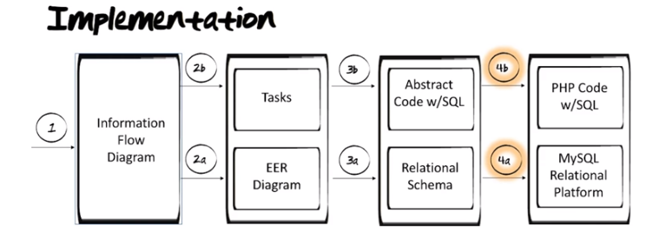

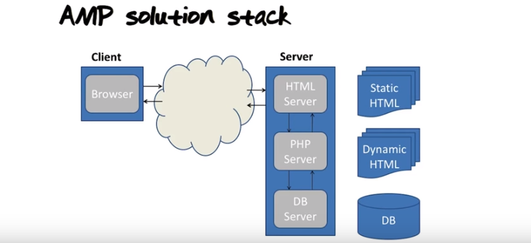
上圖中最後一列說得好.

From online:
WAMP is sometimes used as an abbreviated name for the software stack Windows, Apache, MySQL, PHP. It is derived from LAMP which stands for Linux, Apache, MySQL, and PHP. As the name implies, while LAMP is used on Linux servers, WAMP is used on Windows servers. Because WordPress isn’t usually installed on Windows Servers, WAMP has become popular among developers as a method of installing WordPress on their personal computers.
The “A” in WAMP stands for Apache. Apache is server software that is used to serve webpages. Whenever someone types in your WordPress website’s URL, Apache is the software that “serves” your WordPress site.
The “M” in WAMP stands for MySQL. MySQL is a database management system. It’s job in the software stack is to store all of your website’s content, user profiles, comments, etc.
The “P” in WAMP stands for PHP. PHP is the programming language that WordPress is written in. It is also the piece that holds the entire software stack together. It runs as a process in Apache and communicates with the MySQL database to dynamically build your webpages.

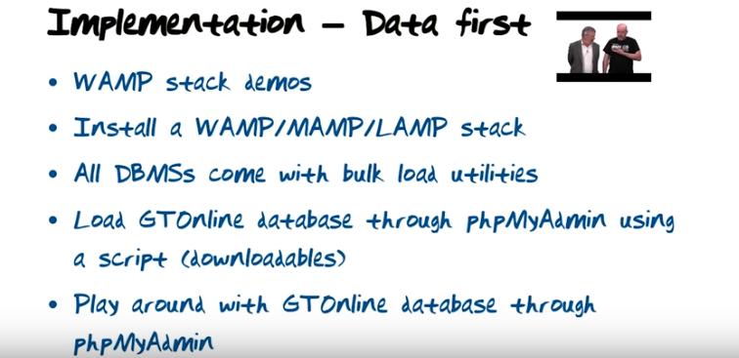

下載LAMP: https://bitnami.com/stack/lamp
安裝時, 會出現Create MySQL 'root' Account提示, the root account is what's going to have all the access to the database.

Find the sql port:
mysql -uroot -p
mysql> SHOW GLOBAL VARIABLES LIKE 'PORT';

videos 8-13:

